|  |  |  |  |
| --- | --- | --- | --- |
|  |  | **Worksheet - HTTP in Action** | logo-teal.png |

**Using the Developer Tools**

Most modern browsers include a set of Developer Tools designed to provide a detailed look into your browser’s activity. It is possible to monitor the traffic of HTTP requests and responses associated with a web page in real time.

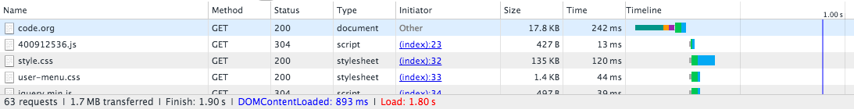

Use the links below to help you navigate to the Developer Tools of your browser. In Chrome, Internet Explorer and Firefox you’ll need to **open the “Network” tab.**

Chrome: <https://developers.google.com/web/tools/chrome-devtools/>

Internet Explorer: <https://msdn.microsoft.com/library/bg182326(v=vs.85)>

Firefox: <https://developer.mozilla.org/en-US/docs/Tools/Network_Monitor>

Safari: <https://developer.apple.com/safari/tools/> (look at the “Network Requests” in the “Timelines” tab.)

**Seeing HTTP in Action**

You will use your browser’s developer tools to discover what kind of HTTP traffic is associated with visiting different types of websites. You and your partner are going to look at least 5 different types of websites:

1. [http://example.com](https://example.com/) -- a very simple web page. Use this first to investigate developer tools.
2. **A “static” website** like: Wikipedia
3. **A news website** like: ESPN.com, BuzzFeed, the New York Times, etc.
4. **A streaming site** like: YouTube, or Spotify
5. **A site that accepts user input** like: twitter, facebook, email, google docs.

For each type of website below, follow these steps:

1. Monitor the HTTP traffic generated by loading the page.
2. Once the page has loaded, poke around with the other information the developer tools let you see about the data coming in. What about the protocols can you see?
3. Interact with the website by clicking links or using other functionality on the site, noting how this affects the HTTP traffic.
4. Observe other things like:
   * Total amount of data received
   * Number of HTTP requests actually generated by loading one page
   * Total time to load the page.
   * Types of data received through HTTP (it’s more than just HTML)

**Make notes about any questions you have or things that are interesting and worth sharing with other groups.**

- The majority of methods are GET, occasionally a POST or two

- Wikipedia makes mostly imageset and script requests when the page loads, and XHR, json, and img requests when you start scrolling

- Static websites like wikiedpia or mehvix.com load fast, while interactive / dynamic sites like YouTube request a lot more data, making them a lot slower

- If you reqest a site document that doesn’t exist, it will return a 404 (e.g. <https://en.wikipedia.org/aslkfjealkjs>)

- What are some other statuses besides 404 and 200?

- Is there a limit to the maximum request size?

- TLSv1.2 is used by wikipedia and buzz, while TLSv1.3 is used by Google sites (YouTube, drive, etc.)

-